Spring Data JPA - Quick Example:
Let us create a new spring data jpa project using spring initializr / sping starter project by sts plugin in eclipse.
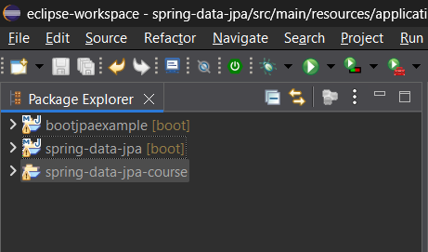
Create a package for entities – com.springdatajpa.springboot.entity
Also create the a separate package for repositories of these entitites
Com.springdatajpa.springboot.repository
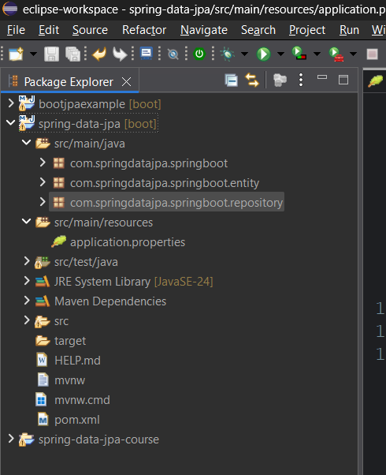

Now we need to create the entities – entities are nothing but java objects which are mapped to the relational database.
For every entity we have a separate table in the database and the fields/ properties of the object becomes the columns of the table. This happens using ORM (object relational mapping by spring data Jpa).
for that we need to create a data base connectivity and add required dependencies.
Adding required dependencies:
While creating the project itself we can specify the dependencies which we want to add as follows
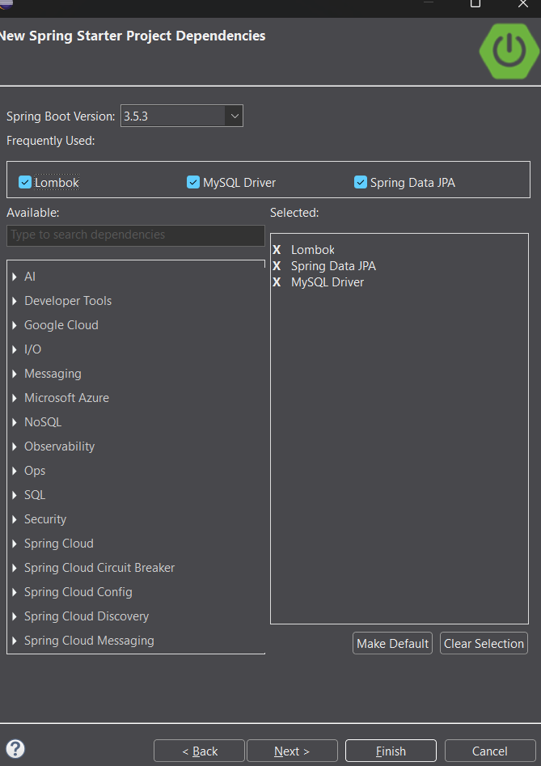
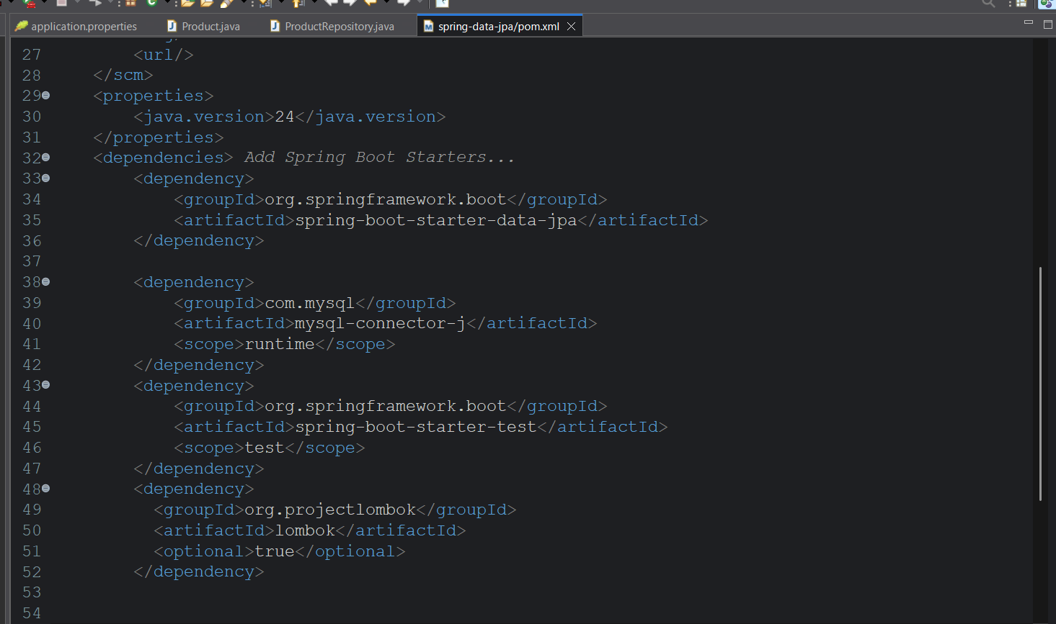
Fill the application.properties file to connect to the mysql database
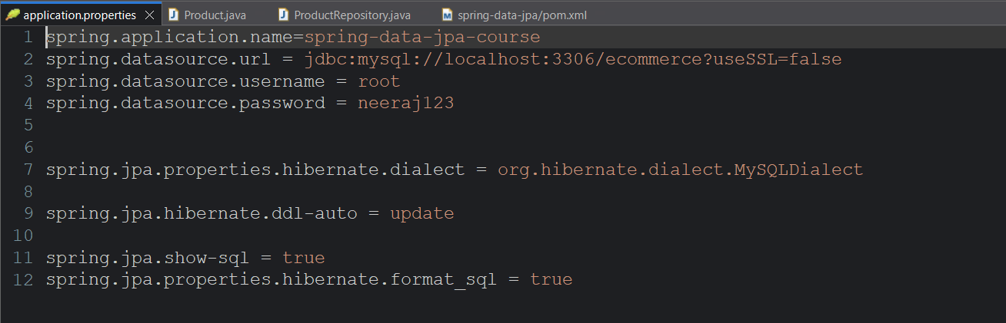
I have created a database with name ecommerce in the mysql database to do all my operation and store the entities in that data base.
Now the product class which we are going create is stored as a table in this database.

Now create a product class and add appropriate fields
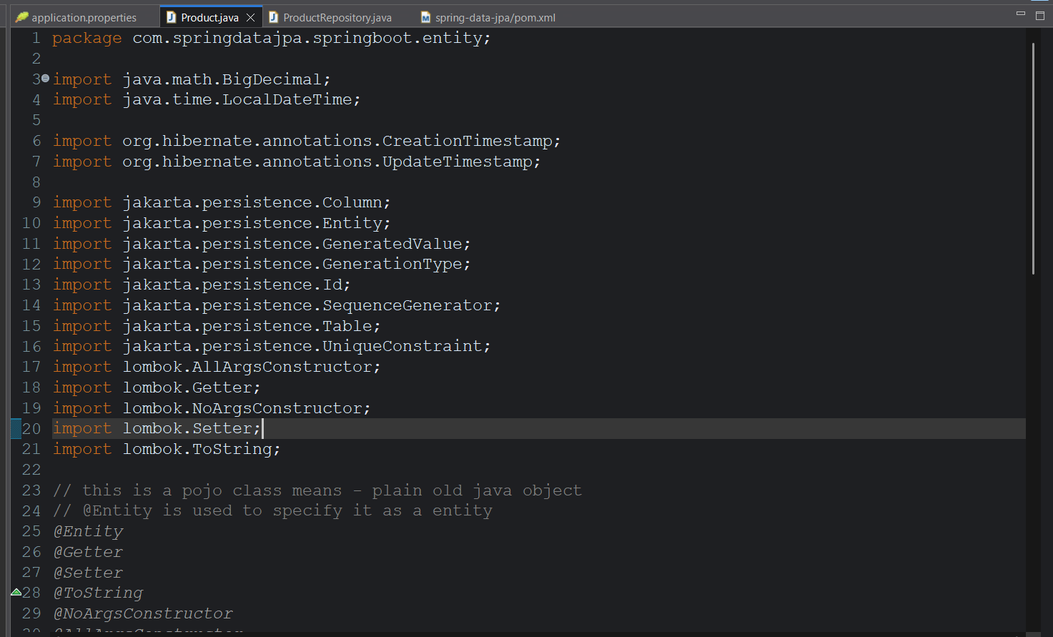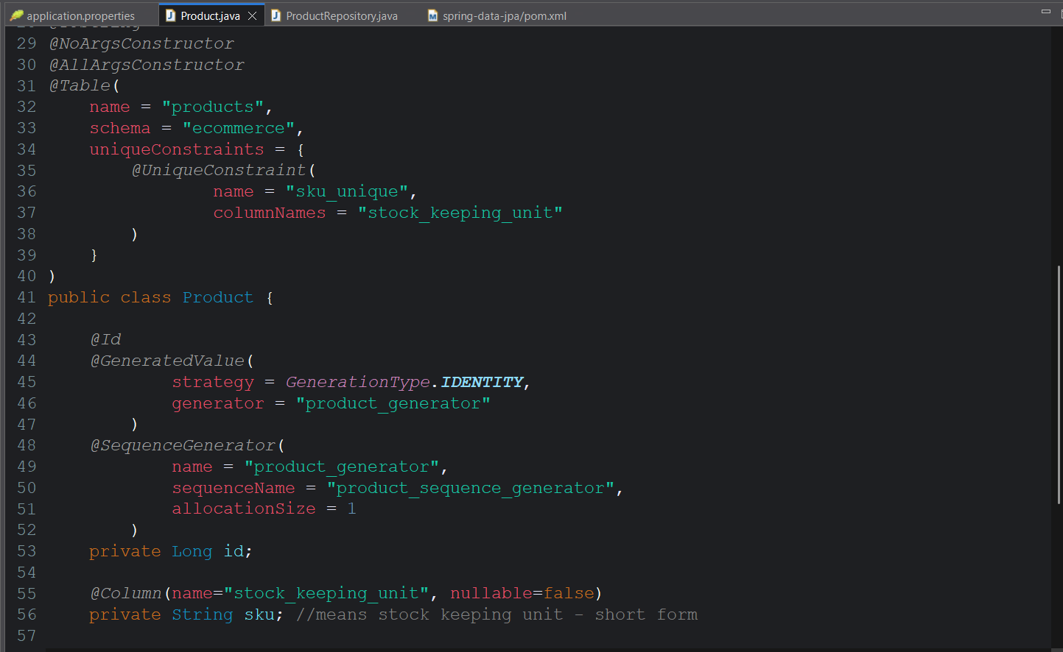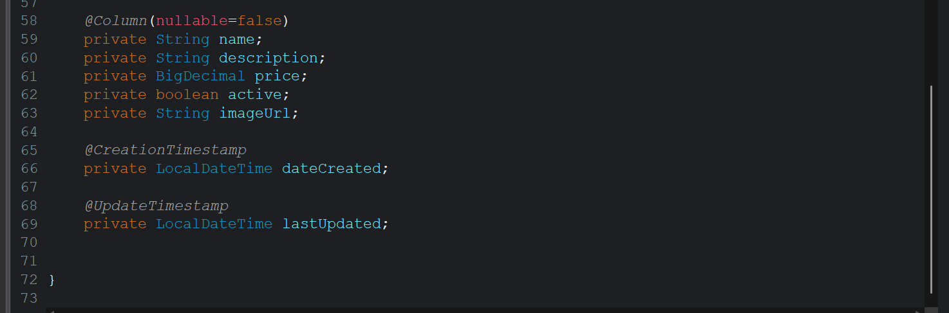
Also create a new repository interface in the repositories package which gives the crud functionalities by extending the JpaRepository class
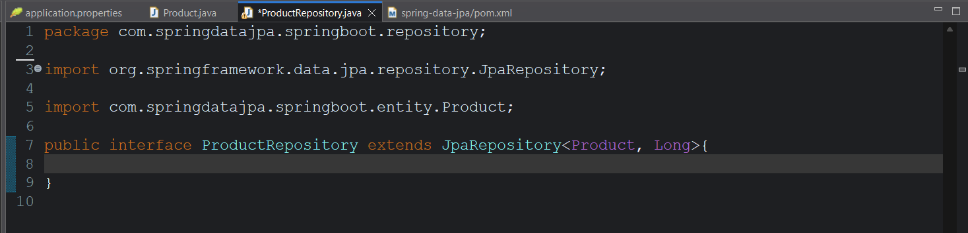

We also see the product table in MySql work bench
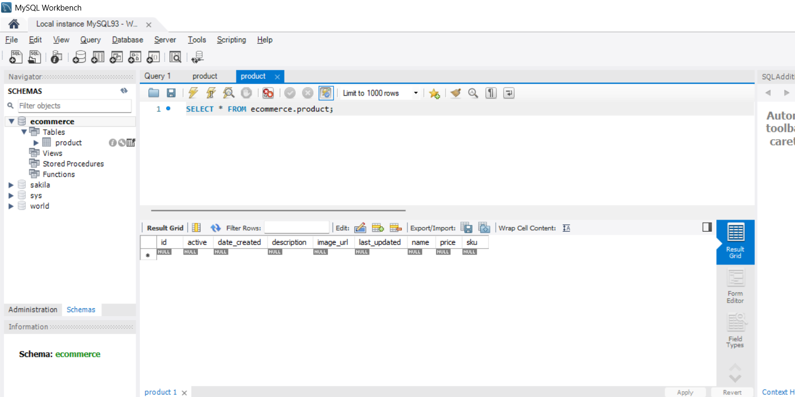
Now perform CRUD operations using test class. Create a package com.springdatajpa.springboot.repository .
Create a new test class inside that package.


Now we can perform CRUD operations in this Test class.

- CRUD operations code is in the attached code folder.

